

**Western Australian Certificate of Education**

**ATAR course examination, 2020**

**Question/Answer Booklet**

11 PHYSICS

Name

**Test 2 - Forces and Energy**

|  |  |  |  |  |  |  |  |  |  |  |
| --- | --- | --- | --- | --- | --- | --- | --- | --- | --- | --- |
| Student Number: In figures |  |  |  |  |  |  |  |  |  |  |

**Mark: $\frac{}{\text{33}}$**  In words

#### Time allowed for this paper

Reading time before commencing work: five minutes

Working time for paper: fifty minutes

**Materials required/recommended for this paper**

To be provided by the supervisor

This Question/Answer Booklet

Formulae and Data Booklet

***To be provided by the candidate***

Standard items: pens, (blue/black preferred), pencils (including coloured), sharpener, correction fluid/tape, eraser, ruler, highlighters

Special items: non-programmable calculators satisfying the conditions set by the School Curriculum and Standards Authority for this course

**Important note to candidates**

No other items may be taken into the examination room. It is your responsibility to ensure that you do not have any unauthorised notes or other items of a non-personal nature in the examination room. If you have any unauthorised material with you, hand it to the supervisor before reading any further.

**Structure of this paper**

|  |  |  |  |  |  |
| --- | --- | --- | --- | --- | --- |
| Section | Number of questions available | Number of questions to be answered | Suggested working time  (minutes) | Marks available | Percentage of exam |
| Section One:  Short Answers |  |  |  |  |  |
| Section Two:  Problem-solving | 6 | 6 | 50 | 33 | 100 |
| Section Three:  Comprehension |  |  |  |  |  |
|  |  |  |  | **Total** | 100 |

**Instructions to candidates**

1. The rules for the conduct of examinations at Holy Cross College are detailed in the College Examination Policy*.* Sitting this examination implies that you agree to abide by these rules.

2. Write your answers in this Question/Answer Booklet.

3. Working or reasoning should be clearly shown when calculating or estimating answers.

4. You must be careful to confine your responses to the specific questions asked and to follow any instructions that are specific to a particular question.

5. Spare pages are included at the end of this booklet. They can be used for planning your

responses and/or as additional space if required to continue an answer.

• Planning: If you use the spare pages for planning, indicate this clearly at the top of the page.

• Continuing an answer: If you need to use the space to continue an answer, indicate in the original answer space where the answer is continued, i.e. give the page number.

Fill in the number of the question(s) that you are continuing to answer at the top of the page.

6. Answers to questions involving calculations should be ***evaluated and given in decimal***

***form*.** It is suggested that you quote all answers to ***three significant figures***, with the

exception of questions for which estimates are required. Despite an incorrect final result, credit may be obtained for method and working, providing these are ***clearly and legibly set out***.

7. Questions containing the instruction "estimate" may give insufficient numerical data for their solution. Students should provide appropriate figures to enable an approximate solution to be obtained. Give final answers to a maximum of two significant figures and include appropriate units where applicable.

8. Note that when an answer is a vector quantity, it must be given with magnitude and direction.

9. In all calculations, units must be consistent throughout your working.

1. A white pool ball of mass 0.200 kg is moving with a velocity of 1.60 ms-1 East and collides with a stationary striped ball of the same mass. If the striped ball moves off with a velocity of

1.90 ms-1 East:

(a)   calculate the velocity of the white ball after the collision. (3 marks)

(b)   show by calculation whether the collision is elastic. (3 marks)

2. A bullet of mass 8.00 g is stationary in the barrel of a gun of mass 4.00 kg. The trigger is pulled and a force of 2.80 x 103 N is exerted on the bullet for 1.70 ms.

(a) What is the impulse that acted on the bullet? (3 marks)

(b) Determine the velocity of the bullet as it leaves the barrel of the gun. (4 marks)

3. A bullet of mass 25.0 g is fired horizontally into a sand-filled box that is suspended by long strings in the ceiling. The combined mass of the bullet, box and sand is 10.0 kg. After impact, the box swings upwards to reach a maximum height of 0.100 m as shown in the diagram.

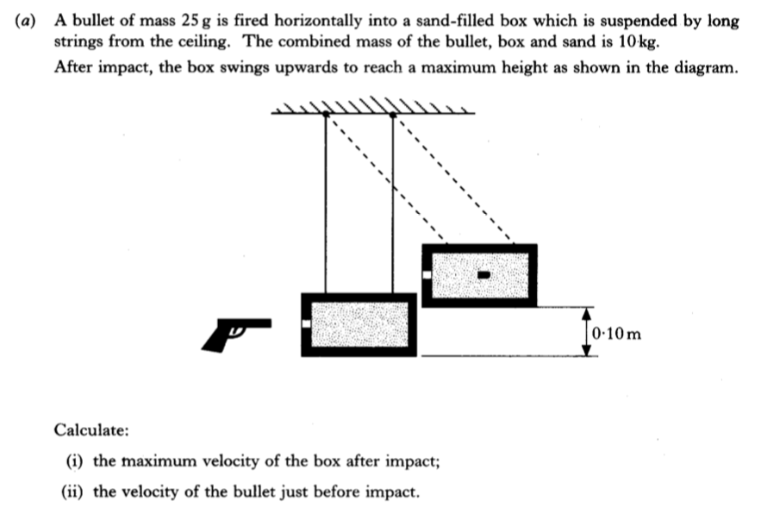

Using Conservation of Mechanical Energy, calculate the maximum speed of the bullet, sand and box just after the bullet embeds itself. (4 marks)

4. A 47.5 kg woman is riding an elevator ***down*** 3 stories.

(a) What is the woman’s weight? (2 marks)

(b) If her apparent weight as the elevator is slowing down near the ground floor is 495 N, what is her acceleration? (3 marks)

5. A rope is attached to a 50.0 kg crate to pull it up a frictionless incline at a constant speed of 2.00 ms-1 to a height of 3.00 m.

A diagram of the situation and a free-body diagram are shown below. Note that the force of gravity has two components (parallel and perpendicular component); the parallel component balances the applied force and the perpendicular component balances the normal force.

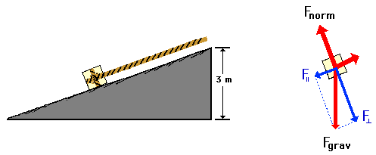

(a) Of the forces acting upon the crate, which one(s) do work upon it? Circle your answer(s). (2 marks)

(b) Determine how much work is required to move the crate to the top of the incline.

(3 marks)

6. A popular roller-coaster ride has a loop-the-loop in it as shown in the diagram below.

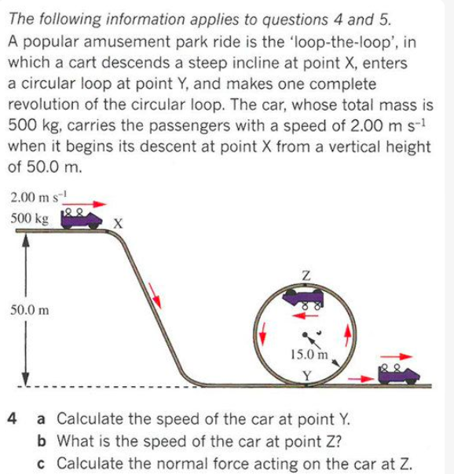

The car, which has a total mass of 5.00 x 102 kg, carries the passengers at 2.00 ms-1 at

point X, which is a vertical height of 50.0 m above the lowest point.

(a) Determine the energy of the car at point X. (3 marks)

(b) Calculate the speed of the car through point Z. (3 marks)